1. **Remote Controller (Mx-16s)**

This chapter makes a brief introduction about how to set switch to the channel in remote controller, to get the switch state in copter and to do the calibration.

* 1. **Channel Setting of Remote Controller (Mx-16s)**

1. Turn on the power and select “Ja”, then you can see the following main interface.

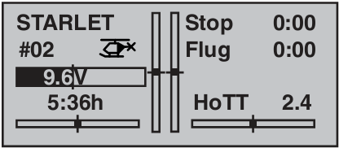

1. Press “ENTER” button and move to the option “Gebereinst”.

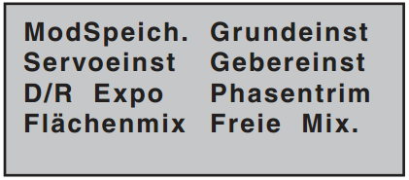

1. Enter the option, then all the available channels are shown blow.

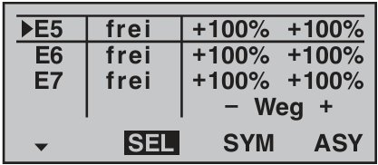

1. Choose a channel you want. For instance, here we want to set switch” SW3” to Channel 5. Press “SELECT” button, a prompting message appears which asks you to set the switch you want.

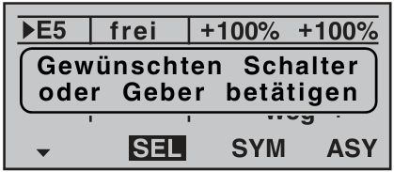

1. Turn on or off the switch to finish setting. Now the switch “SW3” is bound to channel 5.

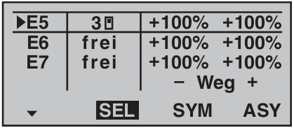

* 1. **Getting Switch State in copter**
     1. **Change in QH_remote.c**

The following function allows the copter to get the signal value from channel 5 to 8 in remote controller which is saved in signalbuffer.

uint8 ReadSwitch(int SwitchID){

uint8 signal;

signal=readPtr[SwitchID+3];

switch(SwitchID){

case 1: return (signal==255? 1:0);break;

case 2: return (signal==255? 1:0);break;

case 3: return (signal==255? 1:0);break;

case 4: return (signal==255? 2:(signal==128? 1:0));break;

}

}

* + 1. **Change in copter.h**

This file contains structs describing the copters actual state.

The state of 4 switches should be added.

Struct CopterState

/* Switch State*/

uint8 switch1;

uint8 switch2;

uint8 switch3;

uint8 switch4;

* + 1. **Change in main.c**

The main.c contains the starting point of the software.

The following codes are added to get the switchstate every 20ms.

if (timerIsFlagSet(TIMER_FLAG_20MS))

{

copterGetStatePtr()->switch1=ReadSwitch(1);

copterGetStatePtr()->switch2=ReadSwitch(2);

copterGetStatePtr()->switch3=ReadSwitch(3);

copterGetStatePtr()->switch4=ReadSwitch(4);

}

* 1. **Calibration of Remote Controller (Mx-16s)**

Calibration should be done every time when you flash the program again.

Turn on the copter and the remote controller, then move the left lever of the controller to the top right corner and move the right one to the lower right corner and then a beep will be heard from the quadcopter which indicates a successful calibration.

The detailed operation of calibration is as follows.

